**Step by Step process on setting up my developer environment**

The following tools were used to set up my developer environment:

1. Windows 11 laptop (64 bit)
2. Stable internet network
3. Chrome
4. Youtube

# Installing a Text editor

1.1 Go to <https://code.visualstudio.com/Download>

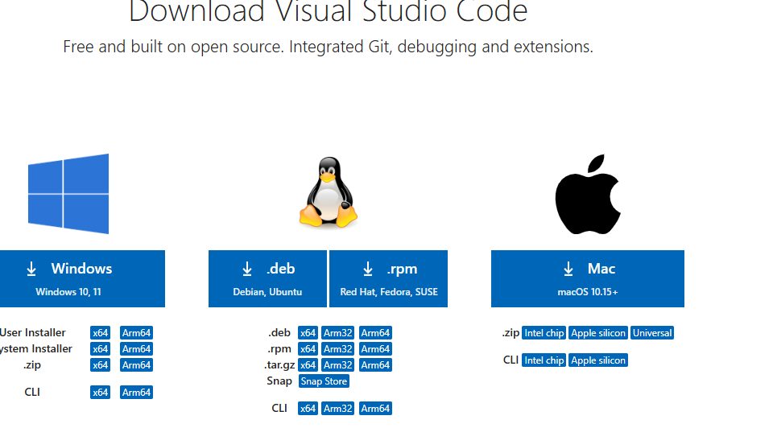

1.2 Click on windows

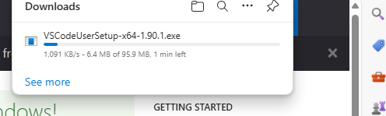

1.3 This will pop-up. After this run the installer.

1.4 Once the download completes locate the downloaded file, which can be found in downloads

1.5 Once the file is found double click on the file. The installation process will start.

1.6 A prompt will pop up asking for permission to allow the installer make changes to your device. Click Yes

1.7 The installer will show some set up options. You can leave this as their default options

1.8 Click on the next button until you see the install button then click on install

1.9 Once the installation is complete, a finish button will pop up click on it.

1. 10 Go to start then launch VS

## Installing git

1. Visit the official Git website: [git-scm.com](https://git-scm.com/).
2. Locate the download for windows button

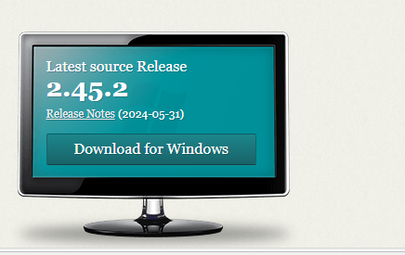

It looks something like this, click on it.

1. After clicking on it another tab will pop up



1. Tap on click here to download. Then a prompt will appear

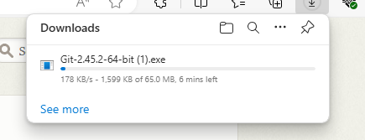

1. After the installation is complete locate the file in the file explorer. After locating it click on it then an installation wizard will appear.

* Follow the installation wizard steps:
  + - Select the installation directory.
    - Choose components (default options are usually fine).
    - Select an editor (default is typically Vim, you can change this to Nano or another editor if you prefer).
    - Adjust PATH environment (choose "Use Git from the Windows Command Prompt" or "Use Git from Git Bash only" depending on your preference).
    - Choose HTTPS transport backend (default is usually fine).

1. After the Git installation is complete it is necessary to configure it.
2. Locate the command prompt and open it as an administrator.
3. Then type the following code to configure git

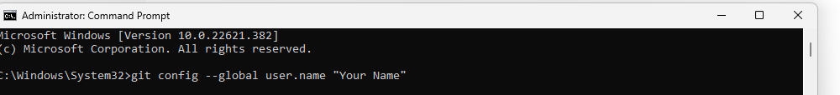



1. After this you can verify your configuration using the following code

git config --global –list

## How to install python

1. Go to [www.python.org/downloads/windows/](http://www.python.org/downloads/windows/)
2. Click on Download windows installer (64 bit)
3. After that a prompt will show, showing that python is being installed
4. Once the installation is complete locate the document in the file explorer and double click on it. An installation will commence
5. Once the installation completes, open a command prompt:

* Type python --version to verify that Python has been installed correctly.

## How to install MYSQL

1. Visit the official MySQL website: [mysql.com](https://www.mysql.com/).

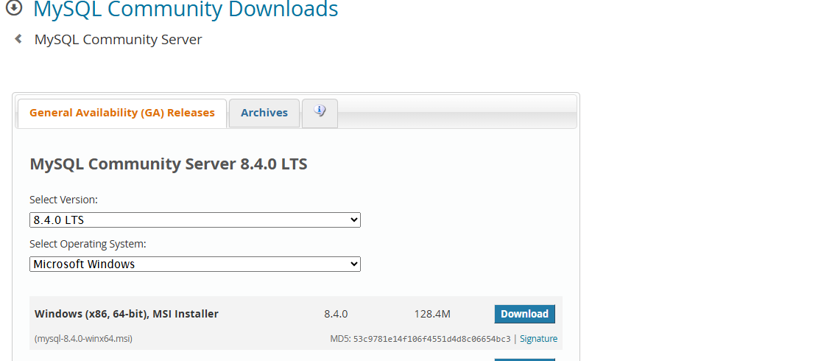

1. Navigate to the Downloads section.
2. Click on "MySQL Community (GPL) Downloads".
3. Scroll down and find the MySQL Installer for Windows. Download the installer appropriate for your system (usually a web community installer).
4. Once the download completes, locate the downloaded installer
5. Double-click the installer to launch it.
6. The MySQL Installer launches with a Setup Wizard. Follow these steps:
   * Select "Developer Default click "Next".
   * Choose the MySQL Server version you want to install. Click "Next"
   * Click "Execute" to begin the installation process.
   * Wait for the installer to download and install MySQL Server and other necessary
   * components.
   * Then the next step is to configure MYSQL. Click "Execute" to begin the installation process.
   * Wait for the installer to download and install MySQL Server and other necessary components.
   * Choose "Use Strong Password Encryption for Authentication".
   * input a strong password that you can easily remember. Then click on “next
   * Open a Command Prompt:
   * Type mysql -u root -p and press Enter.
   * Enter the root password you set during installation when prompted.
   * If MySQL successfully starts, you will see the MySQL command-line client prompt (mysql>).

# Challenges faced while setting up my environment

After installing MySQL and opening the command prompt to complete the setup. This message popped up:

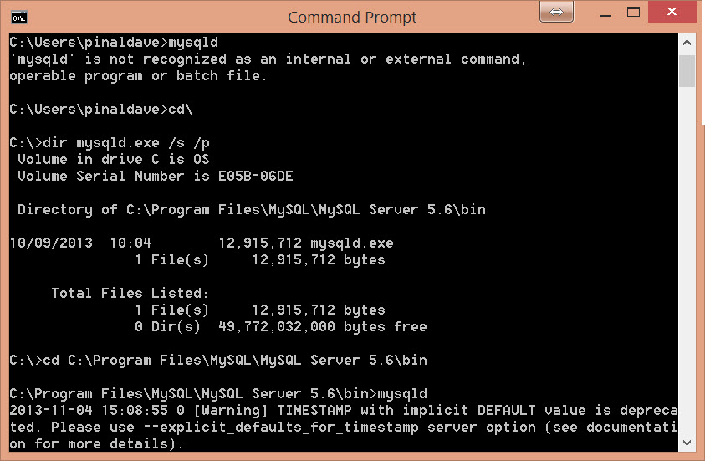

I solved this issue by doing the following:

1. First of all, I went to YouTube to find out what the issue may be
2. Then I proceeded to my file explorer and located the MYSQL folder
3. Within the folder is a bin file, I copied the path
4. After which I went to start and searched for environmental variables. Clicked on run as administrator.
5. Located path, clicked on it, then clicked on new.
6. After that I pasted the path then saved the changes.
7. Went back to my command prompt
8. Typed MySQL -u root -p and press Enter.
9. Enter the root password you set during installation when prompted.
10. If MySQL successfully starts, you will see the MySQL command-line client prompt (MySQL>).